Speaking and Listening

- Talk clearly and loudly enough to be understood by others.
- Listen attentively to others and respond appropriately.
- Take turns when speaking without interrupting others.
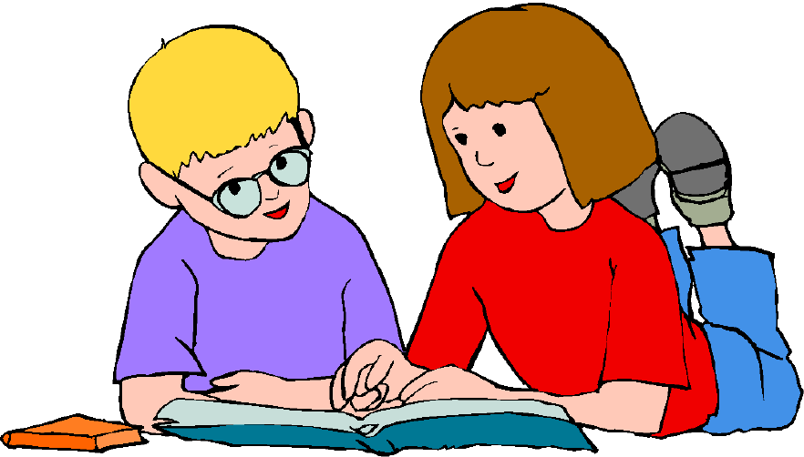
- Ask questions to get more information
- Re-tell a well-known story

Reading

- Read accurately and confidently words of 2 or more syllables.
- Identify which words appear again and again – use patterns in stories.
- Relate reading to their own experiences.
- Re-read to correct.
- Re-tell a story with considerable accuracy.
- Discuss the significance of title and make simple predictions about a story.
- Explain what they understand about a story, share ideas and listen to others.
- Talk about their favourite stories and poems.
- Know the difference between fiction and non-fiction.
- Be secure in the use of Year 1 phonics to blend and read words.

Writing
- Read and write the capital letter form of each letter.
- Write sentences that start with a capital letter and end with a full stop.
- Use ‘and’ to join ideas.
- Use conjunctions to join sentences (e.g. so, but).
- Begin to use tense correctly eg ‘went’ not ‘goed’.
- In writing, show evidence of; full stops, question marks, exclamation marks.
- Use capital letters for names and personal pronoun ‘I’.
- Write clearly sequenced sentences.
- Correct formation of capital and lower case – starting and finishing in right place.
- Correct formation of digits.
- Can spell Year 1 words using phonic skills, spell words with prefixes and suffixes, and spell compound and plural words.
Mathematics

- Count to 100, forwards and backwards from any number.
- Read and write numbers to 20 in digits and words.
- Read and write numbers to 100 in digits.
- Say 1 more and1 less than numbers to 100.
- Count in multiples of 1, 2, 5 and 10.
- Know number bonds to 10 by heart.
- Use bonds and subtraction facts to 20.
- Add and subtract 1 digit and 2 digit numbers to 20, including zero.
- Add any three 1-digit numbers with a total up to 20.
- Solve simple multiplication and division with apparatus and arrays.
- Recognise half and quarter of object, shape or quantity.
- Sequence events in order.
- Know months of the year in order.
- Use the language of day, week, month and year.
- Know o’clock and half past using analogue clock.
- Recognise and name a range of simple 2d and 3d shapes.
- Recognise a range of simple measures including length, mass, capacity time.
- Recognise a range of coins and know their value.

