Speaking and Listening
- Talk about experiences giving detail and using descriptive language.
- Think of a range of questions to ask a visitor.
- To work in a group, listening, taking turns and volunteering ideas.
- Listen and build on what a previous speaker has said.
- To retell a story using linking words, to perform a poem.
- To begin to recognise that formal and informal situations require different language.

Reading
- To decode automatically, reading unknown words using their phonics knowledge.
- Read aloud with fluency, accuracy and expression.
- Comment on plot, setting and characters in familiar and unfamiliar stories.
- Recount main themes and events.
- Comment on the structure of the text.
- Draw simple inferences from the events and characters’ actions.
- Use commas, question marks and exclamation marks to vary expression.
- Recognise quotation marks and read speech with a character voice.
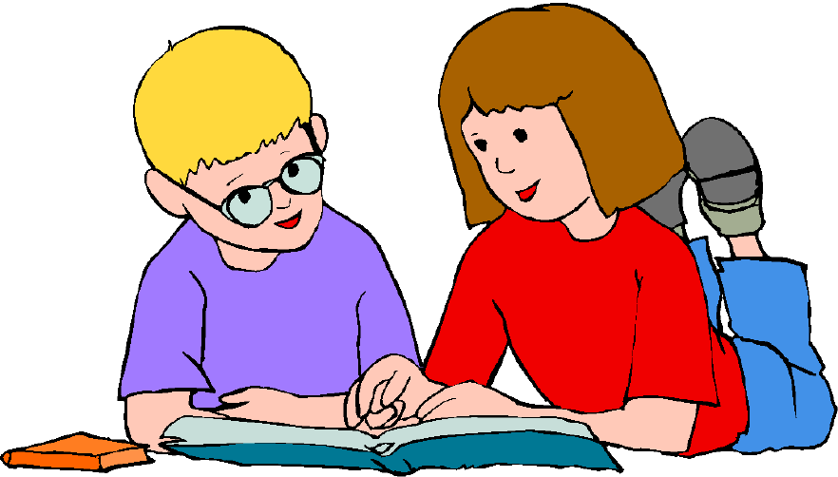
- Identify past and present tense.
- Use contents and index pages to locate information in non-fiction.
- Be secure reading words using their Year 2 Phonics.

Writing
- To write narratives about personal experiences and those of others, both real and fictional.
- To think, say, write, read (check) in order to maintain form in their writing.
- Write different kinds of sentences: statement, question, exclamation, command.
- Use expanded noun phrases to add description and specification.
- Use conjunctions (when, if, that, because, or) for subordination.
- Correct and consistent use of present tense and past tense.
- Correct use of verb tenses.
- Correct and consistent use of a wider range of punctuation: capital letters, full stops, questions marks, exclamation marks and commas in a list.
- Be able to use an apostrophe for omission of letters (wasn’t) and for simple possession (Luke’s car).
- Understand speech marks.
- Handwriting to be the correct size, beginning to be joined, numbers and letters formed correctly.
- Can spell year 2 words using phonic skills, spell words with prefixes and suffixes, and spell compound and plural words.

Mathematics
- Compare and order numbers up to 100.
- Read and write all numbers to 100 in digits and words.
- Say 10 more/less than any number to 100.
- Count in multiples of 2, 3, 5 and 10 from any number up to 100.
- Recall and use multiplication and division facts for 2, 5 and 10 times tables.
- Recall and use +/- facts to 20.
- Recognise place value of any 2-digit number.

Add and subtract:
- 2-digit and 1-digit numbers (43+6)
- 2-digit and 10s numbers (45-20)
- Two 2-digit numbers (13+34)
- Three 1-digit numbers (4+5+7)

- Recognise and use inverse (14+5=19, so 19-5=14 - 3x5=15 so 15÷3=5)
- Calculate and write multiplication and division maths stories using multiplication tables.
- Recognise, find, name and write 1/3; 1/4; 2/4; 3/4.
- Recognise equivalence of simple fractions (2/4 = ½)
- Solve problems involving the four operations, applying their increasing knowledge of mental and written methods.

Shape, Space, Measure & Data:

- Tell the time to five minutes, including quarter past/to.
- Know months of the year in order.
- Use different coins to make the same amount – e.g. make 50p in different ways.
- Read scales in divisions of ones, twos, fives and tens when measuring.
- To describe the properties of a range of 2d and 3d shapes including recognising lines of symmetry and right angles.
- Interpret and construct simple pictograms, tally charts, block graphs and simple tables.
- Use mathematical vocabulary (angle, quarter turn, clockwise, anti-clockwise) to describe position and movement.
