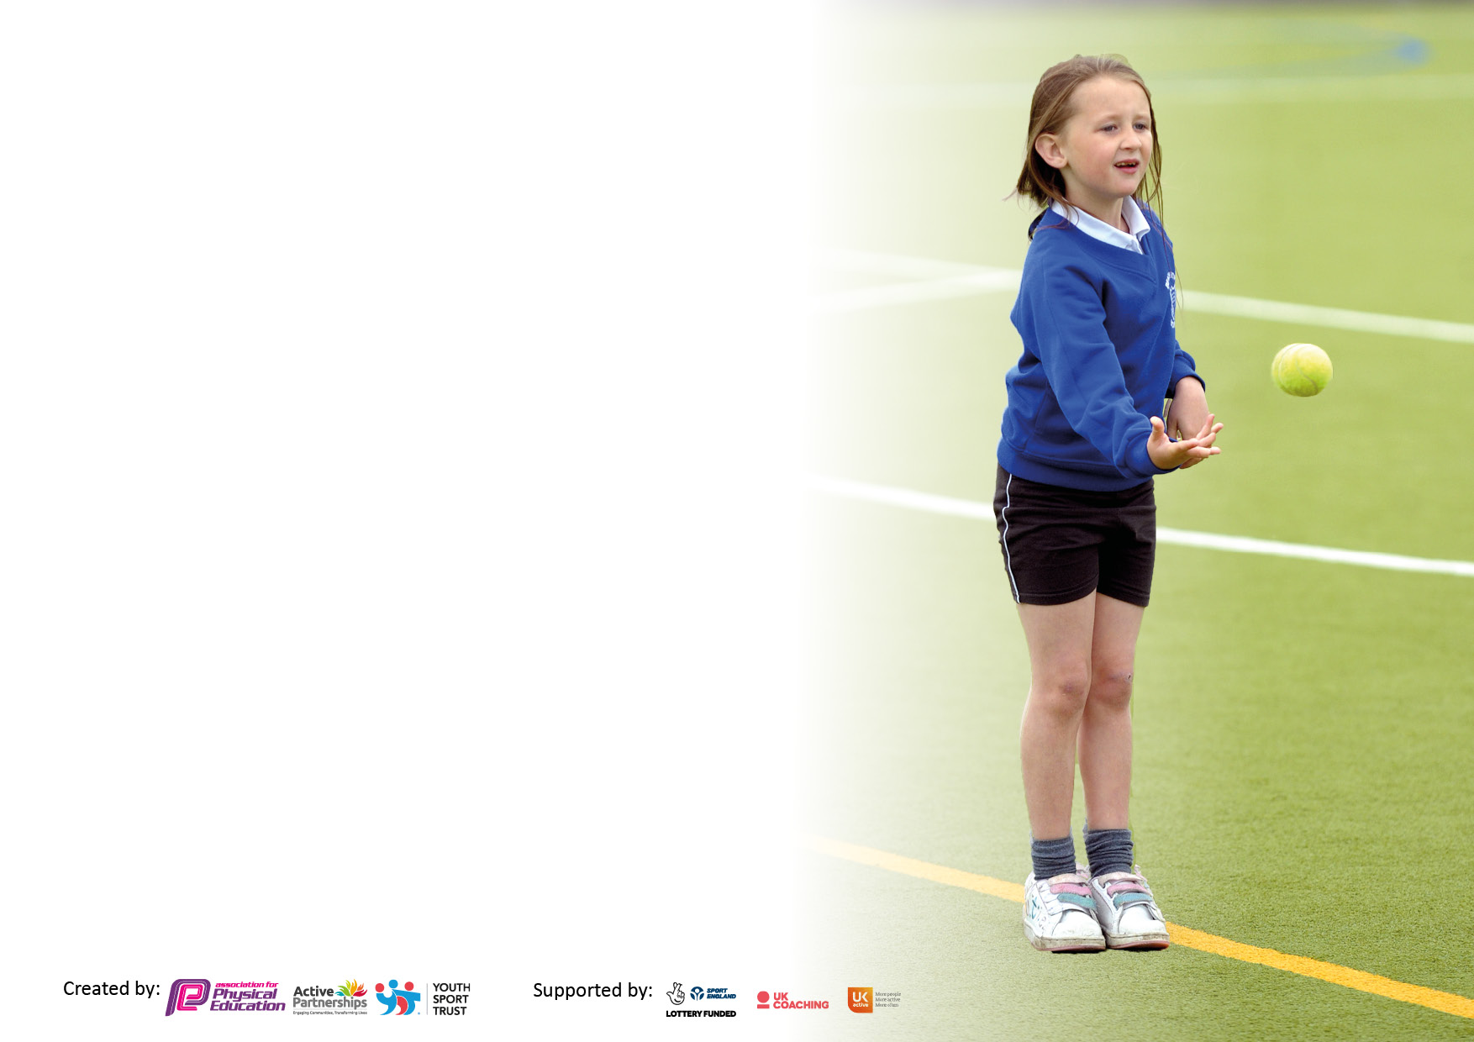

It is important that your grant is used effectively and based on school need. The Education Inspection Framework makes clear there will be a focus on **‘whether leaders and those responsible for governors all understand their respective roles and perform these in a way that enhances the effectiveness of the school’**.

Under the Quality of Education Ofsted inspectors consider:

**Intent** - Curriculum design, coverage and appropriateness

**Implementation** - Curriculum delivery, Teaching (pedagogy) and Assessment

**Impact** - Attainment and progress

To assist schools with common transferable language this template has been developed to utilise the same three headings which should make your plans easily transferable between working documents.

Schools must use the funding to make **additional and sustainable** improvements to the quality of Physical Education, School Sport and Physical Activity (PESSPA) they offer. This means that you should use the Primary PE and sport premium to:

* Develop or add to the PESSPA activities that your school already offer
* Build capacity and capability within the school to ensure that improvements made now will benefit pupils joining the school in future years
* The Primary PE and sport premium should not be used to fund capital spend projects; the school’s budget should fund these.

Please visit gov.uk for the revised DfE guidance including the 5 key indicators across which schools should demonstrate. This document will help you to review your provision and to report your spend. DfE encourages schools to use this template as an effective way of meeting the reporting requirements of the Primary PE and Sport Premium.

We recommend you start by reflecting on the impact of current provision and reviewing the previous spend.

Schools are required to publish details of how they spend this funding, including any under-spend from 2021/2022, as well as on the impact it has on pupils’ PE and sport participation and attainment. **All funding must be spent by 31st July 2023.**

We recommend regularly updating the table and publishing it on your website throughout the year. This evidences your ongoing self-evaluation of how you are using the funding to secure maximum, sustainable impact. Final copy must be posted on your website by the end of the academic year and no later than the 31st July 2023. To see an example of how to complete the table please click HERE.

**Details with regard to funding**

Please complete the table below.

|  |  |
| --- | --- |
| Total amount carried over from 2021/22 | £0 |
| Total amount allocated for 2021/22 | £18,050 |
| How much (if any) do you intend to carry over from this total fund into 2022/23? | £0 |
| Total amount allocated for 2022/23 | £18,050 |
| Total amount of funding for 2022/23. To be spent and reported on by 31st July 2023. | £17,764.40 |

**Swimming Data**

Please report on your Swimming Data below.

|  |  |
| --- | --- |
| Meeting national curriculum requirements for swimming and water safety.  N.B. Complete this section to your best ability. For example you might have practised safe self-rescue techniques on dry land which you can then transfer to the pool when school swimming restarts.  **Due to exceptional circumstances priority should be given to ensuring that pupils can perform safe self rescue even if they do not fully meet the first two requirements of the NC programme of study** |  |
| What percentage of your current Year 6 cohort swim competently, confidently and proficiently over a distance of at least 25 metres?  **N.B.** Even though your pupils may swim in another year please report on their attainment on leaving primary school at the end of the summer term 2022.  Please see note above | 73% |
| What percentage of your current Year 6 cohort use a range of strokes effectively [for example, front crawl, backstroke and breaststroke]?  Please see note above | 73% |
| **What percentage of your current Year 6 cohort perform safe self-rescue in different water-based situations?** | 73% |
| Schools can choose to use the Primary PE and sport premium to provide additional provision for swimming but this must be for activity **over and above** the national curriculum requirements. Have you used it in this way? | Yes |

**Action Plan and Budget Tracking**

Capture your intended annual spend against the 5 key indicators. Clarify the success criteria and evidence of impact that you intend to measure to evaluate for pupils today and for the future.

|  |  |  |  |  |
| --- | --- | --- | --- | --- |
| **Academic Year:** 2022/23 | **Total fund allocated:** | **Date Updated:** | |  |
| **Key indicator 1:** The engagement of all pupils in regular physical activity – Chief Medical Officers guidelines recommend that primary school pupils undertake at least 30 minutes of physical activity a day in school | | | | Percentage of total allocation: |
| *£9,608.58 (54%)* |
| **Intent** | **Implementation** | | **Impact** |  |
| **Your school focus should be clear what you want the pupils to know and be able to do and about**  **what they need to learn and to**  **consolidate through practice:** | **Make sure your actions to achieve are linked to your intentions:** | **Funding allocated:** | **Evidence of impact: what do pupils now know and what can they now do? What has changed?:** | **Sustainability and suggested next steps:** |
| *Pupils to engage in physical activities during playtime and lunchtime. Playground PALS to promote this.*  *Pupils access different play equipment during break time and lunchtime.*  *Enhance the provision for swimming* | *Deploy PE Teacher and TA Play Leader across the school from FS2 to Y6. Use all outside areas (including the woodland areas) to encourage and engage the pupils in physical activities.*  *Pupils have access to different equipment which will promote active playtimes*  *Provide further swimming lesson opportunities for pupils who have not met the expected standard. Pupils identified from the swimming register.* | *PE Teacher £2,282.40 TA*  *Playleader £2,003.56*  *Field Rent £1,800.00*  *£1649.18*  *£1873.44* | *Pupils experience a wealth of physical exercise throughout the school day. They are encouraged to stay active in different parts of the outside areas*  *During break time and lunchtime, pupils have been able to play badminton, rugby, table tennis, basketball, netball and handball.*  *Pupils in Year 3 have received four additional 45 minutes swimming lessons as part of the curriculum. Year 5/6 pupils who have not met the required standard have received 8 additional sessions.* | *PE Teacher and Play Leader have marked out areas of the school grounds and playground and these encourage different active stations. However, extensive funds are needed from next year’s budget to get the playgrounds repainted so that marking help create more purposeful zones, as well as aiding pupils in their activities and play.*  *Monitor use of equipment and replenish appropriately in the next academic year.*  *Pupil outcomes will be more closely monitored in 23-24 so that all pupils in KS2 are given ample time and opportunity to meet the required standard* |
| **Key indicator 2:** The profile of PESSPA being raised across the school as a tool for whole school improvement | | | | Percentage of total allocation: |
| *£1,854.48 (10%)* |
| **Intent** | **Implementation** | | **Impact** |  |
| **Your school focus should be clear what you want the pupils to know and be able to do and about**  **what they need to learn and to**  **consolidate through practice:** | **Make sure your actions to achieve are linked to your intentions:** | **Funding allocated:** | **Evidence of impact: what do pupils now know and what can they now do? What has changed?:** | **Sustainability and suggested next steps:** |
| *Sports Coach employed as early intervention to teach age-appropriate PE skills to enhance hand-eye coordination as this links to pupils’ development and progress in fine motor skills.*  *Pupils to experience a fun and enjoyable Sports Day each June.*  *Playground PALS receive training from PE Teacher to facilitate activities, games and competitions at lunchtime.* | *Pupils to take part in various sporting activities, building up age-appropriate skills on a weekly basis. Sports coach employed three times a week.*  *Pupils to take part in various sports as shown in video link:*  [*Sports Day 1.MOV (sharepoint.com)*](https://srscmatderbyshire-my.sharepoint.com/personal/msingleton_pri_srscmat_co_uk/_layouts/15/stream.aspx?id=%2Fpersonal%2Fmsingleton%5Fpri%5Fsrscmat%5Fco%5Fuk%2FDocuments%2FAttachments%2FSports%20Day%201%2EMOV&wdLOR=cFF092A9E%2DDACE%2D445F%2D9BBD%2D68DA3278CFFE&ct=1687186167144&or=Outlook-Body&cid=22548D45-6C5D-48D7-B354-E5091F5F8C52&ga=1)  *Playground PALS to receive training in the Autumn Term to learn how to run activities, games and competitions at lunchtimes for younger pupils.* | *£1,474.64*  *£78.65*  *£301.19* | *Pupils speak positively about the different activities they have experienced and the skills they have learned. Teacher reports and assessments record the progress and impact across other curriculum areas.*  *Pupils speak positively about the different activities they have experienced. Pupils have an appreciation and real enjoyment of the sports on offer and all pupils can see that they have contributed and achieved.*  *Playground PALS are able to use leadership skills they had learned in preparation. Younger pupils speak positively about the*  *different activities they have experienced.* | *Pupils have made greater gains than previous cohorts (all of whom did not receive this bespoke programme of PE age-specific skills being taught). Look to continue to deliver similar provision next year.*  *Each year our Sports Day gets better and better. Comments from the parents, pupils and colleagues is overwhelmingly positive. Continue in 2023/2024*  *New cohort of Playground PALS to receive training in the Autumn Term 2023.* |

|  |  |  |  |  |
| --- | --- | --- | --- | --- |
| **Key indicator 3:** Increased confidence, knowledge and skills of all staff in teaching PE and sport | | | | Percentage of total allocation: |
| £2,406.43 (13%) |
| **Intent** | **Implementation** | | **Impact** |  |
| **Your school focus should be clear** | **Make sure your actions to** | **Funding** | **Evidence of impact: what do** | **Sustainability and suggested** |
| **what you want the pupils to know** | **achieve are linked to your** | **allocated:** | **pupils now know and what** | **next steps:** |
| **and be able to do and about** | **intentions:** |  | **can they now do? What has** |  |
| **what they need to learn and to** |  |  | **changed?:** |  |
| **consolidate through practice:** |  |  |  |  |
| *Review the progression of skills, vocabulary and knowledge so they are mapped out throughout*  *the school within Primary PE Passport to include the full range of activities and sports.*  *Develop knowledge and skills of PE lead within school to share with and support other staff in the teaching of PE.*  *Develop knowledge and skills of PE leaders within school so that they can lead and manage the subject effectively.* | *Each sport has a progression of skills, vocabulary and knowledge clearly mapped out, and user friendly for teaching staff to follow, so they can teach lessons effectively*  *School PE Co-ordinator to attend PE networks, co-ordinator meetings to discuss best practice and present to teachers the progression of skills, vocabulary and knowledge to increase their understanding.*  *School PE Leader non-contact time to manage the PE across the school and to prepare staff updates/CPD – 2 days for PE Teacher too* | *£399*  *Get Set 4 PE software £1,375.00*  *PE Leader £474.20*  *PE Teacher*  *£158.23* | *The intended objectives have been taught by teachers within school. Pupil voice indicates that pupils can talk about the skills and knowledge they have learned. Pupils can identify and explain the key vocabulary linked to each sport.*  *The intended objectives are taught well by teachers. Pupil voice indicates pupils are able to talk about the skills and knowledge learned. Teachers have grown in understanding and are more confident to teach PE.*  *Subject led and managed in line with Ofsted expectations – members of staff receive guidance and advice when teaching curriculum PE and school sports.* | *Primary PE Passport has enabled PE to be delivered and taught to a good level. This is now a resource that has ended this year as school has been able to use a new programme (Get Set 4 PE) to plan the progression of skills, vocabulary and knowledge so they are mapped out throughout the school to enable all staff to be more au fait and more effective when teaching PE.*  *Get Set 4 PE to support teaching and learning and the progression of skills, vocabulary and knowledge for the next three years mapped out in: Fundamentals, Ball skills, Target Games, Sending and Receiving skills, Dance, Gymnastics, Fitness, Invasion Games, Net and Wall, Athletics, Striking and Fielding, Football, Cricket, Basketball, Fitness, Handball, Tag Rugby, Tennis, Rounders, Hockey, and Badminton*  *Continue to build in regular subject area management time to ensure that leaders have optimum effectiveness in working to implement changes and strategies that impact on pupils’ progress.* |
| **Key indicator 4:** Broader experience of a range of sports and activities offered to all pupils | | | | Percentage of total allocation: |
| £3,794.91 (21%) |
| **Intent** | **Implementation** | | **Impact** |  |
| **Your school focus should be clear** | **Make sure your actions to** | **Funding** | **Evidence of impact: what do** | **Sustainability and suggested** |
| **what you want the pupils to know** | **achieve are linked to your** | **allocated:** | **pupils now know and what** | **next steps:** |
| **and be able to do and about** | **intentions:** |  | **can they now do? What has** |  |
| **what they need to learn and to** |  |  | **changed?:** |  |
| **consolidate through practice:** |  |  |  |  |
| *Wrap Around – After-School Provision: Increase participation in a wider range of sporting activities.*  *Sensory circuit/walk (half a mile) of the school grounds to support vulnerable pupils with SEND.* | *PE teacher to run football, tag rugby, multi-sports, fitness, handball, rounders, hockey, cricket and athletics after school (timetabled weekly throughout the year on 3 evenings a week).*  *Dance and gymnastics offered throughout the year on one evening a week by the school’s PE Leader. Wrap Around TA to run other sports such as boccia, simple target games, net and wall games, including badminton, table tennis, archery – as well as activities such as board games and crafts.*  *Walk a circuit (0.5 miles) as a strategy for pupils (and staff) to help with mental health and emotional difficulties.* | *PE Teacher £2,523.54*  *TA WAC Playleader £1,271.37*  *From Play leader costs above* | *There is a marked increase in the participation of sports and after school activities due to a range of well thought-out and planned sports and activities from 3.30 to 4.30 each evening.*  *A range of games and activities continue to be provided up until the close of Wrap Around Care at 5.45pm*  *Individual pupils, pairs, small groups and members of staff engage in walking the school’s perimeter (0.5 miles* | *PE teacher linked clubs and activities are popular and run well.*  *There is not enough of a range of activities planned for and delivered in the other areas of the school’s provision – and especially after 4.30pm.*  *Next year, continue to employ our PE Teacher to undertake three evenings each week – to run a range of clubs and sporting events.*  *Continue to employ two TAs who will be linked to ensuring a range of clubs, activities and pupil interests are offered by the school.*  *This has only been used sporadically. Next year, mark out the path better and make the route clearer to help pupils engage with walking as a form of fitness.* |

|  |  |  |  |  |
| --- | --- | --- | --- | --- |
| **Key indicator 5:** Increased participation in competitive sport | | | | Percentage of total allocation: |
| £100.00 (2%) |
| **Intent** | **Implementation** | | **Impact** |  |
| **Your school focus should be clear** | **Make sure your actions to** | **Funding** | **Evidence of impact: what do** | **Sustainability and suggested** |
| **what you want the pupils to know** | **achieve are linked to your** | **allocated:** | **pupils now know and what** | **next steps:** |
| **and be able to do and about** | **intentions:** |  | **can they now do? What has** |  |
| **what they need to learn and to** |  |  | **changed?:** |  |
| **consolidate through practice:** |  |  |  |  |
| *Pupils to engage in sports competitions organised through the Eastwood and District School Sports Association, SRS Trust and internally in school (e.g., Sports Day).*  *Pupils in most year groups (Year 1 to Year 6) have had the opportunity to compete against other external schools in different sports.* | *Pupils have competed in: Tag Rugby, Basketball, Handball, Football, Swimming (Gala), SEND Olympics, Indoor and Outdoor Athletics, Hockey, Throwing, Cross-Country, Boccia and various traditional games and sports*  *Pupils to engage in sports competitions organised through the Eastwood and District School Sports Association, SRS Trust* | *£100*  *Most of the monetary spending comes from overtime payments where various staff members cover or take pupils to sporting events* | *Regular feedback on sports*  *Competitions with fixtures and results shared in assemblies, newsletters, school website and school social media pages.*  *Regular feedback on sports*  *Competitions with fixtures and results shared in assemblies, newsletters, school website and school social media pages.* | *Continue in 2023/2024 and look to extend offer to include competition in other sports such as Dance and Gymnastics.*  *Time, energy, and commitment from a collegiate approach by all members of staff enables this to take place. A hugely successful aspect of spending – but is difficult to cost out as some costs are hidden in the payments of key staff, and additional costs are hidden in the overtime worked to enable these vital events to take place.* |

|  |  |
| --- | --- |
| Signed off by | |
| Head Teacher: |  |
| Date: |  |
| Subject Leader: |  |
| Date: |  |
| Governor: |  |
| Date: |  |